

**SMT201**

**Geographic Information Systems for Urban Planning**

**AY 2024/2025, Term 2**

**GIS Project Report**

**Prepared for :** Prof. Kam Tin Seong

**GIS Group 6**: Anne Saphrin Alex Sathyan, Harshitha Balaji, Lau Liang Jun

***Link to Project Website:***[*https://gisg6kl.netlify.app/*](https://gisg6kl.netlify.app/)

***Link to Github Repository:***[*https://github.com/saphalex/SMT201-GISProject*](https://github.com/saphalex/SMT201-GISProject)

**1.0 Abstract 3**

**2.0 Background & Motivation 4**

**3.0 Project Objectives 5**

3.1 Scope of Work 5

3.2 Project Schedule 6

4.1 Data Collection 7

4.1.1 Area & Image Selection 7

4.1.2 Vector Layer Selections 10

4.2 Image Pre-processing 13

4.4 Classification & Accuracy Assessment using SCP Plugin 19

**5.0 Data Analysis & Discussion 25**

5.1 Change in Land Cover of Selected Land Classes 25

5.1.1 Vegetation 26

5.1.2 Water Bodies 27

5.1.3 Impervious Surfaces 27

5.1.4 Low-Rise Buildings 28

5.1.5 Barren Land 29

5.2 Overall Trend in Land Cover Change 30

5.3 An Example of our Observations: Bukit Tunku 31

**6.0 Limitations 33**

**7.0 Recommendations 33**

**8.0 Future Work 34**

**9.0 References 35**

## **1.0 Abstract**

Beyond Singapore, other south-east asian countries have been undergoing rapid urbanisation and development in order to propel economic growth. Namely, Malaysia’s Kuala Lumpur (“KL”) has been on the rise in terms of urbanisation and consequently, this has led to a greater proclivity to natural disasters such as landslides and flash floods due to environmental degradation. Studies show that Malaysia has been extremely prone to landslide occurrences and is the 10th country with the highest frequency of landslides. Currently, KL has been the greatest contributor to this figure in Malaysia given its rapid urbanisation.

Therefore, we are interested in analysing the effects of landslides and any accompanying phenomena such as flash floods on the changes in land cover that have occurred in KL over the span of 5 years (2020 to 2024).

In this project, we have utilised Sentinel-2 satellite imagery data obtained from Copernicus to perform remote sensing by means of image processing and classification techniques. Additionally, we sourced our vector layers and baseline land cover information from OpenStreetMap (OSM) and delineated sub-regions within KL using Mukim boundary layers for further specific analysis.

After creating any and all layers, we defined 8 different land classes (Natural Vegetation, Managed Vegetation, Water Body, Impervious Surfaces, Built-Up (low-rise buildings), Built-Up (high-rise buildings), Barren Land, Shadow). We then obtained the necessary training and testing samples from these land classes to perform classification using the Semi-Classification Plugin (SCP) and observe changes in specific land classes (Natural Vegetation, Managed Vegetation, Water Body, Impervious Surfaces, Built-Up (low-rise buildings), Barren Land).

From our classification and subsequent observations, we were able to find the following:

1. There was an overall increasing trend in Managed Vegetation composition.
2. There was an overall decreasing trend in Natural Vegetation as well as Impervious Surfaces composition.
3. There was considerable variation in Barren Land and Water Bodies composition.

Notably, we observed sharp increases and decreases in the different land classes from 2023 to 2024, which we believe can be attributed to a major landslide that occurred in Bukit Tunku, KL in April 2023. The overall results also allowed us to observe the varying levels of accuracies across the years, with 2024 having the greatest classification accuracy (Overall Accuracy = 81.3%, Kappa Hat = 0.759) and 2022 having the lowest classification accuracy (Overall Accuracy = 40.4%, Kappa Hat = 0.286). We will dive deeper into our observations and takeaways in the following sections of the report.

## **2.0 Background & Motivation**

Urbanisation has been a top priority for many countries given the economic growth and development it paves way for. Within the South-East Asian context, we understand that apart from Singapore, Malaysia has been undergoing rapid urbanisation, with its urbanisation rate being 77.1% in 2023 and a projected 81.8% in 2030 given an annual urban growth rate of 1.8%. In particular, we observe that KL is currently the largest urban area in the country, generating almost 51% of Malaysia’s Gross Domestic Product (GDP), and will continue to urbanise as the capital of the country.

Unfortunately, this overgrowing urbanisation has been a major contributor to the natural disasters that have been happening in the country and the state. The productivity and consequent economic contribution that has been happening as a result of greater urbanisation in KL over the past years has often come at the expense of existing natural and ecological resources, leading to flash floods and landslides.

In order to understand why this may be the case, it is necessary to first understand what landslides and flash floods are. Landslides are environmental disasters that occur due to the mass movement of material, such as rock, earth or debris, down a slope, whereas flash floods refers to flooding caused by excessive rainfall in a short period of time (6 hours or less).

While urbanisation activities often contribute to various detrimental environmental phenomena, the Urban Heat Island (UHI) effect in particular contributes to higher occurrences of extreme rainfall. This rainfall is triggered by the rapid rise of moist air in the atmosphere (a result of the sun heating the Earth's surface) and often causes intense, localised short-duration rainfall that leads to flash floods.

In the scenario where these flash floods occur, the soil and ground are exposed (often for a prolonged period of time) to rainfall, which saturates it. This reduces its strength and cohesion, leading to slope instability and consequent failure. Additionally, rapid infiltration of water into the soil rapidly increases the water pressure in the ground which the soil is unable to reduce, also resulting in slope instability.

Even if flash floods are not present, actions such as deforestation and illegal logging that are carried out to make way for urban sprawl and development are often not coupled with sufficient compensatory practices, leading to slope, vegetation and drainage disruptions and instabilities. This eventually leads to landslides as the soil and ground erodes and falls.

Given this information, we believe that there is an important topic of discussion to be tackled: how the urbanisation, environmental degradation and consequent selected natural disasters have contributed to land cover changes in the past 5 years. We hope that this analysis will better flesh out the cause-and-effect relationship of these disasters with overall urban development and planning, paving the way for a more sustainable approach to urbanisation and infrastructure/economic growth moving forward.

## **3.0 Project Objectives**

This project seeks to investigate and analyse land cover changes in KL by drawing links between landslides alongside accompanying natural phenomena such as floods and changes in various land classes. The specific objectives of the study are as follows:

1. To detect land cover changes in Kuala Lumpur across the selected time period (2020 to 2024) by using GIS tools to wrangle and analyse satellite imagery and geospatial data.
2. To visualise and classify major land cover categories and identify significant trends in these categories across the span of 5 years (2020 to 2024).
3. To explore, implement, and evaluate appropriate classification methods for land cover analysis within the selected KL boundary.
4. To understand and excavate meaningful insights that aid in understanding the environmental implications of land use changes in relation to urbanisation.

### **3.1 Scope of Work**

Since this project will be focusing on land cover changes in different land classes across a span of 5 years, we will be utilising open-source data platforms such as Copernicus and OSM to obtain our data files and layers to perform remote sensing. After selecting our preferred area of study and collecting necessary data, we will wrangle, prepare and split the data into training and testing samples to classify into the various land classes using SCP. Then, we will analyse the results obtained to identify key changes in land cover for each class. Furthermore, to obtain better knowledge on the subject and provide depth to our findings, we have also conducted research and literature reviews to supplement our analysis.

### **3.2 Project Schedule**

The following image reflects our Gantt chart, which details our project progress and workload allocation:

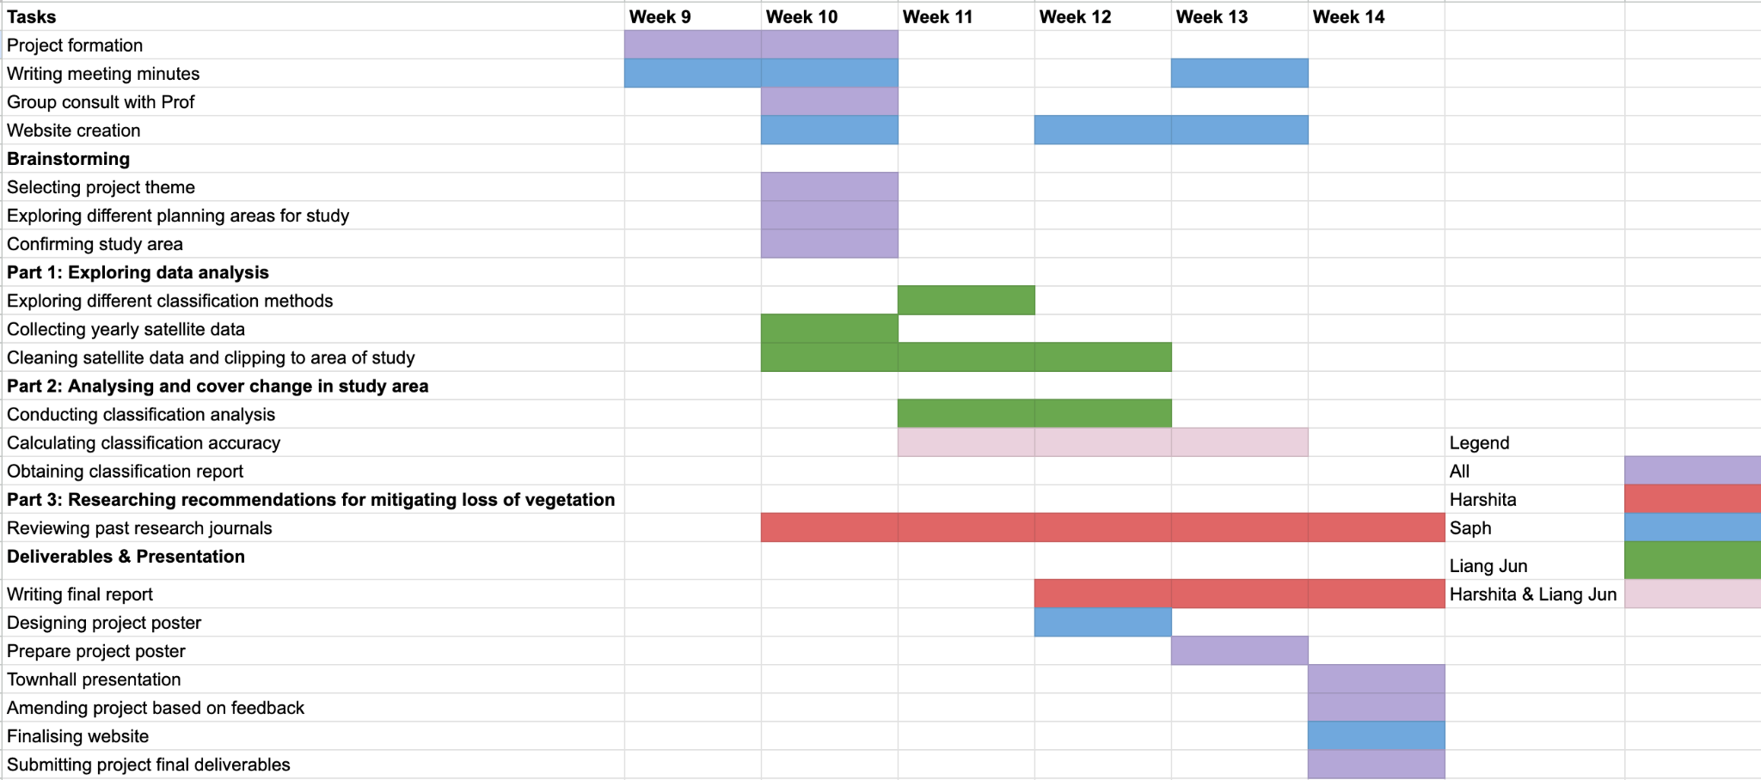

⏶ *Gantt Chart with work distribution*

**4.0 Methodology**

The following diagram details the flow of the methodology adopted to perform land cover change analysis in KL for all years applicable:

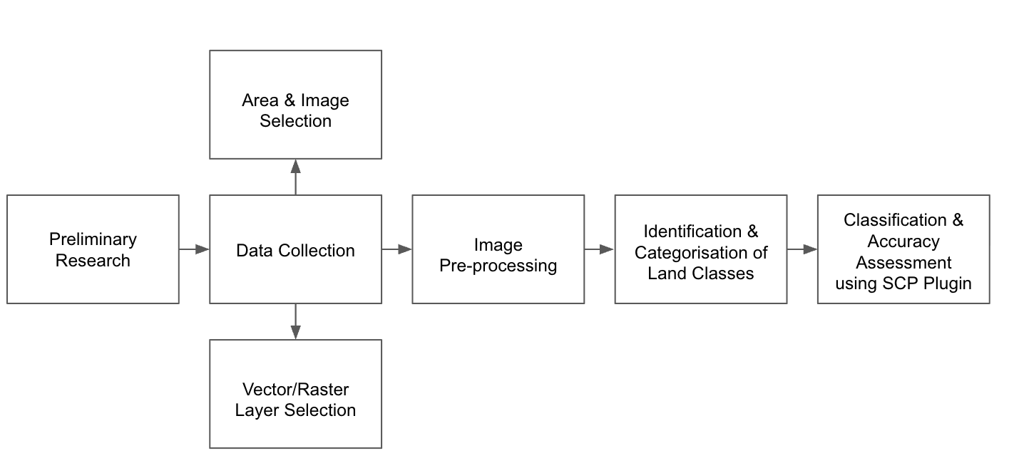

### **4.1 Data Collection**

#### **4.1.1 Area & Image Selection**

After deciding that we would focus on KL for this project, we selected the relevant satellite imagery of the area from Copernicus. Here, we have chosen to use Sentinel-2 data over Landsat 8 data.

Though both Sentinel-2 and Landsat 8 data are excellent, Sentinel-2 is preferred for land cover mapping, especially for dynamic urban areas like Kuala Lumpur. Its 10m resolution better captures smaller urban features such as roads and buildings, as well as fine-scale deforestation. Landsat 8’s 30m resolution often mixes land covers like trees and roads together, causing misclassification.

However, since Sentinel-2 is a relatively newer system, for long-term studies, Landsat 8 has a much larger archive, and 30m resolution would be sufficient if the study was on a continental/much larger scale, requiring large area mapping.

Furthermore, we did not rely on a single image to scope out the area of interest for each year – instead, we ensured that the area was covered by 2 images: right coverage (“right tile”) and middle coverage (“middle tile”). The following table comprises of the image files downloaded from Copernicus for the sake of this project:

| **Year** | **Right Tile** | **Middle Tile** |
| --- | --- | --- |
| **2024** | S2A_MSIL2A_20240227T032711_N0510_R018_T47NRD_20240227T074952.SAFE | S2A_MSIL2A_20240227T032711_N0510_R018_T47NQD_20240227T074952.SAFE |
| **2023** | S2A_MSIL2A_20230314T032511_N0510_R018_T47NRD_20240820T175125.SAFE | S2B_MSIL2A_20230309T032559_N0510_R018_T47NQD_20240823T055939.SAFE |
| **2022** | S2B_MSIL2A_20220113T033109_N0510_R018_T47NRD_20240428T204639.SAFE | S2B_MSIL2A_20220113T033109_N0510_R018_T47NQD_20240428T204639.SAFE |
| **2021** | S2B_MSIL2A_20210207T032919_N0500_R018_T47NRD_20230519T060502.SAFE | S2B_MSIL2A_20210207T032919_N0500_R018_T47NQD_20230519T060502.SAFE |
| **2020** | S2A_MSIL2A_20200228T032701_N0500_R018_T47NRD_20230627T090641.SAFE | S2A_MSIL2A_20200228T032701_N0500_R018_T47NQD_20230627T090641.SAFE |

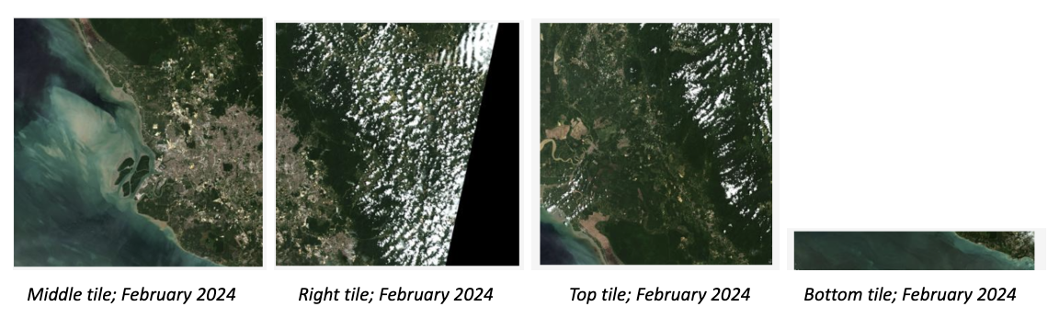

⏶ *The above image shows the 2 tiles selected for the analysis of the KL region in 2024*

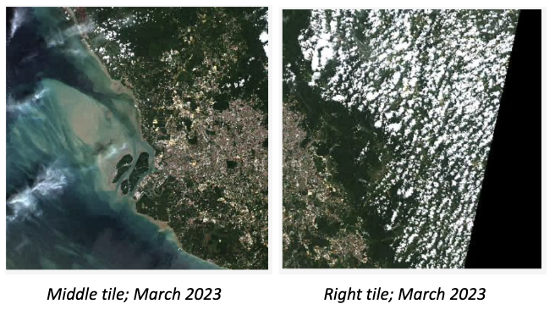

⏶ *The above image shows the 2 tiles selected for the analysis of the KL region in 2023*

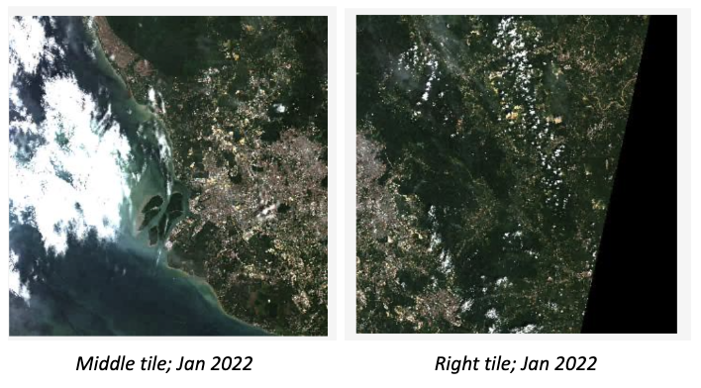

⏶ *The above image shows the 2 tiles selected for the analysis of the KL region in 2022*

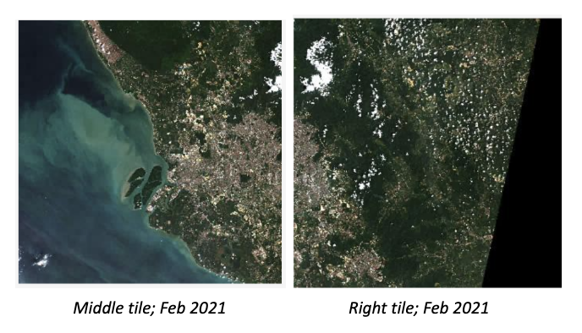

⏶ *The above image shows the 2 tiles selected for the analysis of the KL region in 2021*

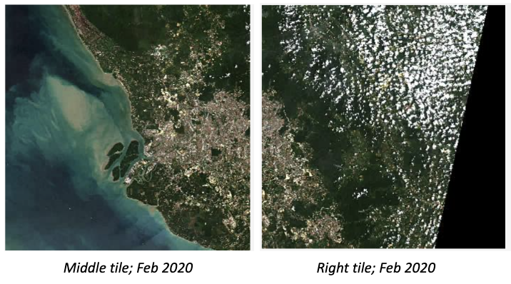

⏶ *The above image shows the 2 tiles selected for the analysis of the KL region in 2020*

To ensure temporal consistency, we tried our best to ensure that the images had a minimum of a 12-month gap between the years (e.g. if we selected images in February for the year 2024, we would ensure that the preceding year’s images would be in either February or January). If this was not possible due to poor imaging or excessive cloud cover, we selected the most suitable image(s) that had the furthest time gap between itself and the following year’s image(s).

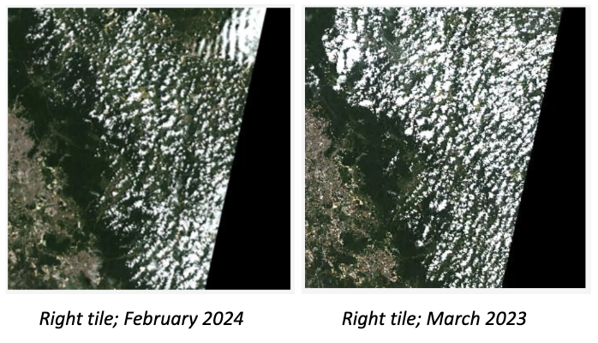

⏶ *The above image shows the right tiles selected for 2024 and 2023. An image in March was selected for 2023 due to the lack of good imaging in January/February.*

We also made sure that for the 2 images selected in each year, they were captured within 1 month of each other and that the quality of the middle tile was prioritised over that of the right tile for any given year’s sample to ensure consistency and quality. Additionally, for any and all images selected, we kept the cloud cover to a minimum. By balancing all these factors, we were able to select the most suitable images for our analysis.

### 

⏶ *The above image shows a side-by-side comparison of the middle tiles selected for 2023 and 2022 that have a time gap of 14 months. This is one of a few outliers from the criteria we had defined for selecting the images.*

#### 

#### 

#### 

#### 

#### 

#### 

#### 

#### **4.1.2 Vector Layer Selections**

We obtained shapefiles for Malaysia through [geoBoundaries.org](http://geoboundaries.org). We first selected the KL boundary from the entire Malaysia map and exported the selected feature to obtain the vector layer.

| Selected KL Boundary from the geoBoundary dataset |
| --- |

Although there were many subzone areas connected to areas outside of KL when overlaying both layers, we still decided to Clip them to preserve the shape of the boundary so that it matches with the boundaries from OpenStreetMap, and also since it was the only open-sourced dataset that contained the sub boundaries for KL.

| KL subzone layer fitting the boundaries of OpenStreetMap (contains many small areas from other subzones) |
| --- |

### 

### 

### 

### 

### **4.2 Image Pre-processing**

Next, for the raster layers, we wanted to combine both the middle and right raster layers with each other. Due to some possible overlapping of images, we did not use the ‘Merge’ function as it gave significantly larger pixel values (reflectance values up to 19000) and used ‘Build Virtual Raster’ instead. We combined the Middle and Right images for each band (bands 2,3,4,8).

| The two images before building The virtual raster layer (combined)  a virtual raster (combining them) |
| --- |

We then clipped them by Mask Extent to the KL Map to obtain the relevant image needed for KL

| Raster layer Clipped by Mask Extent |
| --- |

After obtaining the layers for all 4 10m resolution bands, we then used the Semi-Automatic Classification Plugin (SCP Plugin) to put them together as a band set. By changing the RGB to 3-2-1 (using bands 4,3, then 2), we are able to obtain the True Composite Image (TCI) for the band set. The

TCI allows a quick visual inspection of the land cover types, and allows identification of roads from vegetation, water bodies like reservoirs and rivers, as well as forested areas and bare land.

| True Composite Image for 2020, KL |
| --- |

Then by changing the RGB to 4-3-2 (using bands 8,4, then 3), we are able to obtain the False Composite (FCC) for the band set. The FCC shows vegetation as bright red/pink, urban areas as blue/grey and water bodies as black/dark blue. It can show vegetation clearly and allows impervious surfaces mapping.

| False Colour Composite for 2020, KL |
| --- |

**4.3 Identification & Categorisation of Land Classes**

Using the false and true colour composites obtained as well as the OpenStreetMap trimmed to overlap with the KL subzone boundary, we identified the following land classes and subclasses:

1. Natural Vegetation
   1. Sub-class 1: Forests (*represented on the following spectral plots by *)
2. Managed Vegetation
   1. Sub-class 1: Golf Course grass (*represented on the following spectral plots by *)
   2. Sub-class 2: Sports Field (*represented on the following spectral plots by *)
3. Water Body
   1. Sub-class 1: Flood Reservoir (*represented on the following spectral plots by *)
   2. Sub-class 2: Lakes (*represented on the following spectral plots by *)
   3. Sub-class 3: Rivers (*represented on the following spectral plots by* )
4. Impervious Surfaces
   1. Sub-class 1: Roads (*represented on the following spectral plots by *)
5. Built-up 1 (low-rise buildings)
   1. Sub-class 1: Houses (*represented on the following spectral plots by *)
6. Built-up 2 (high-rise buildings)
   1. Sub-class 1: Buildings (*represented on the following spectral plots by *)
7. Barren Land
   1. Sub-class 1: Empty Lot (Reflective Surfaces) (*represented on the following spectral plots by *)
   2. Sub-class 2: Empty Lot (Reddish-Brown Surfaces) (*represented on the following spectral plots by *)
   3. Sub-class 3: Open Soil (Cemeteries/Parks) (*represented on the following spectral plots by *)
8. Shadow
   1. Sub-class 1: Shadows of Buildings (*represented on the following spectral plots by*)

Therefore, there are a total of 13 sub-classes that we have identified which require training and test data to be selected for. To create the training and test data sets, we utilised the ROI polygon creation feature present in the SCP plug-in, with each polygon representing a data point. For each subclass, we created approximately 80 data points for the training data set and 35 data points for the test data set. Ultimately, the ratio of training data to test data roughly mimicked a 70%-30% split and they must be saved in the correct format (ESRI Shapefiles). This process must be repeated for each year within the selected timeframe.

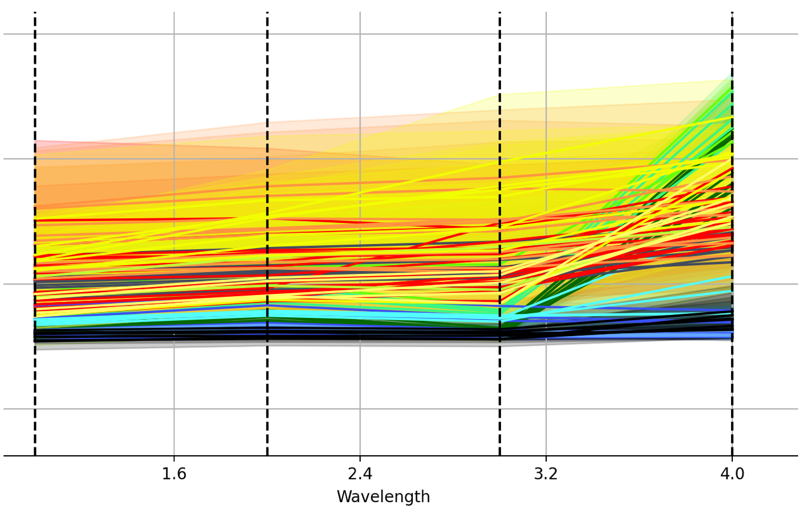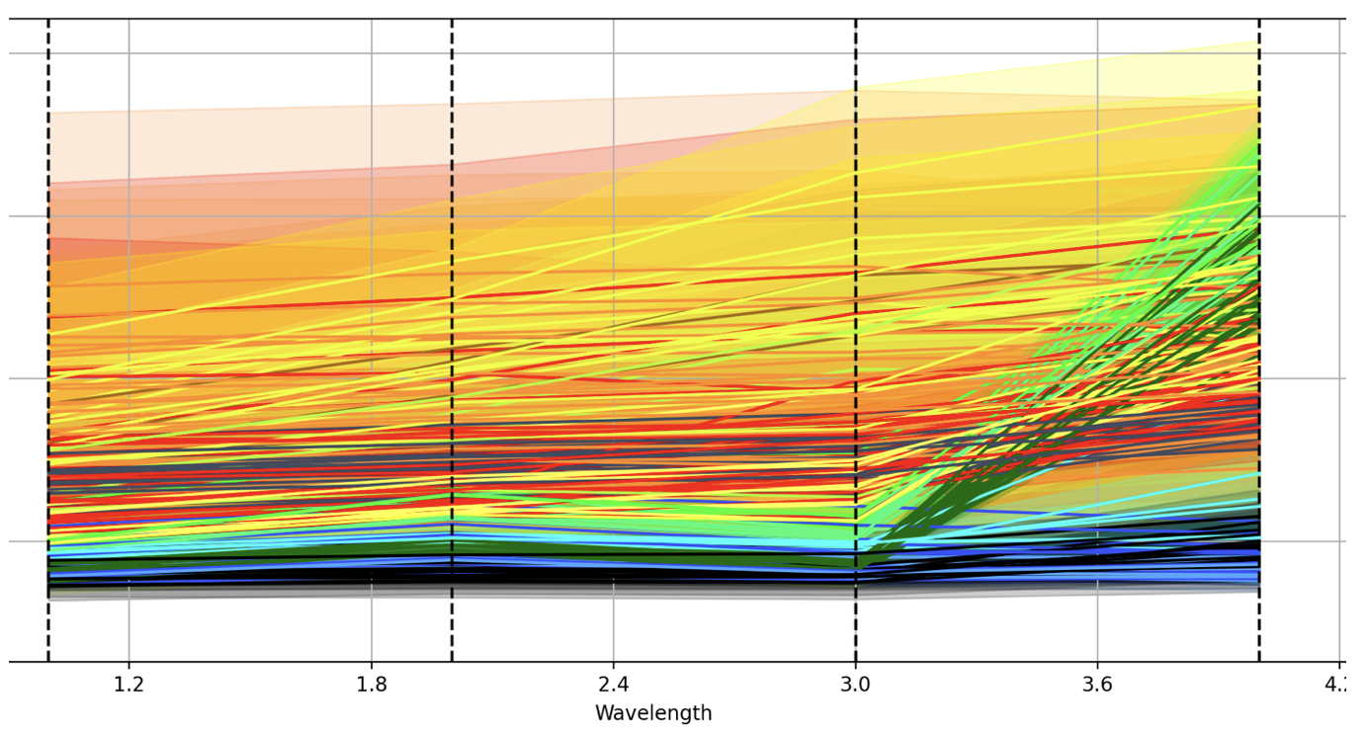

⏶ *Spectral plot of the 2020 training data set*  ⏶ *Spectral plot of the 2020 test data set*

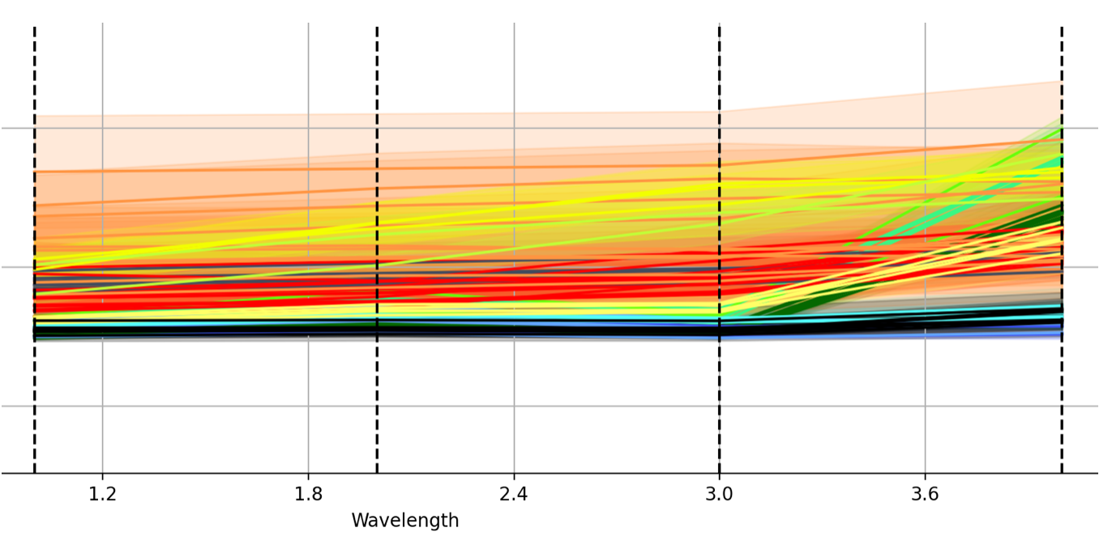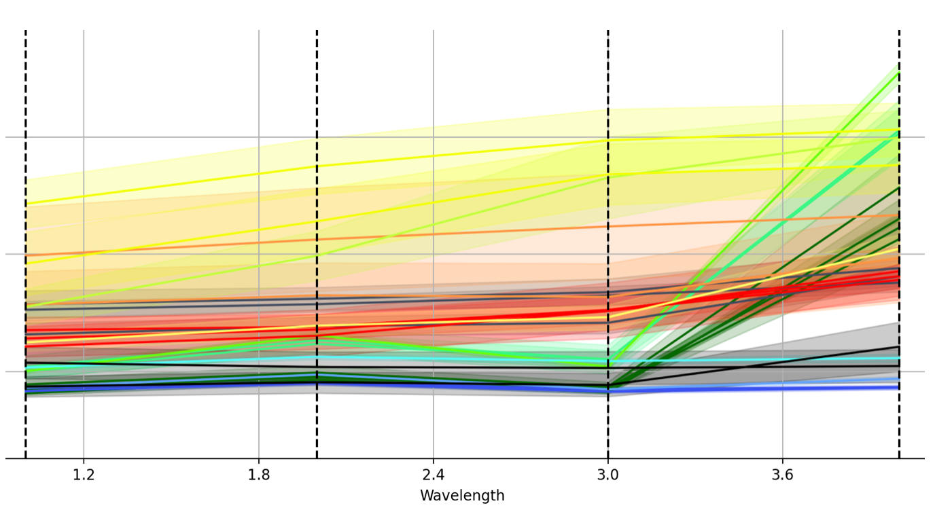

⏶ *Spectral plot of the 2021 training data set*  ⏶ *Spectral plot of the 2021 test data set*

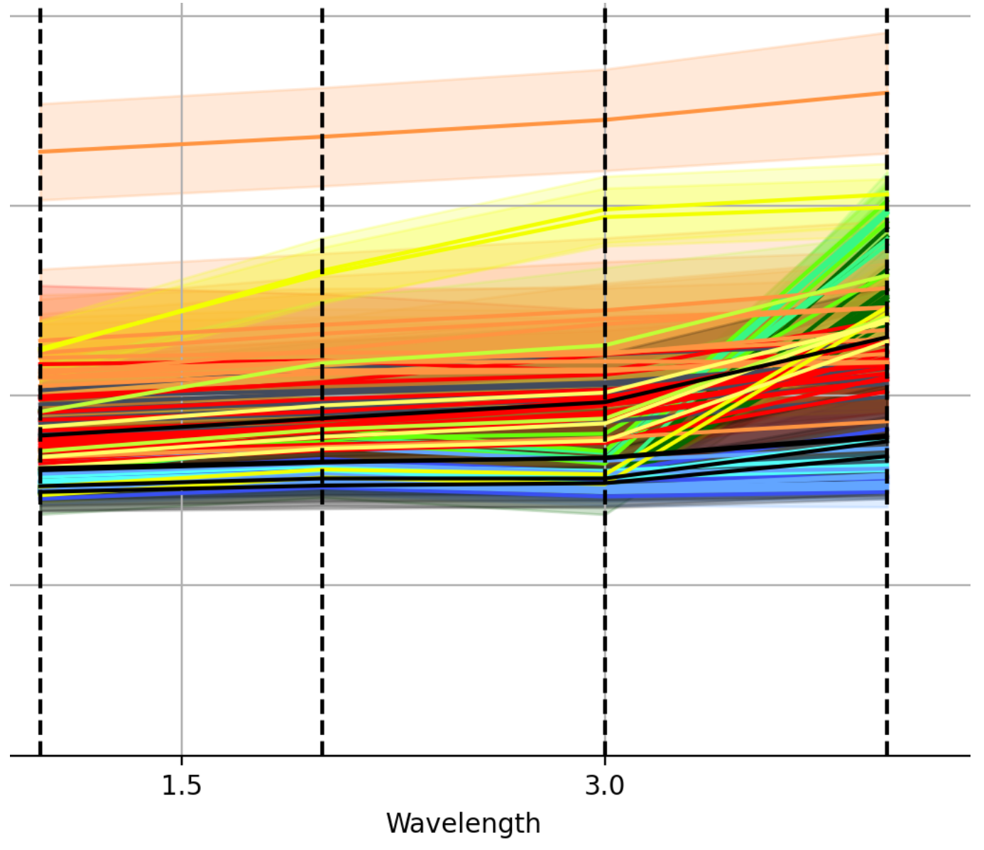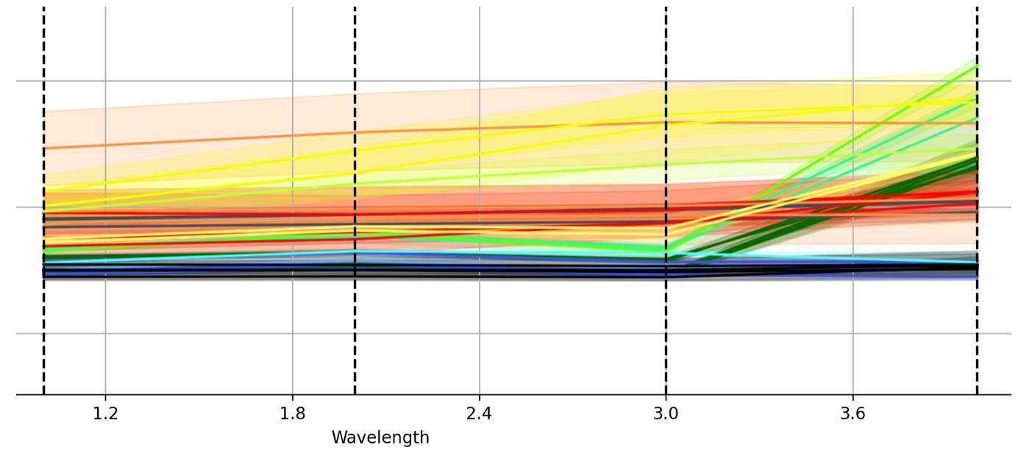

⏶ *Spectral plot of the 2022 training data set*  ⏶ *Spectral plot of the 2022 test data set*

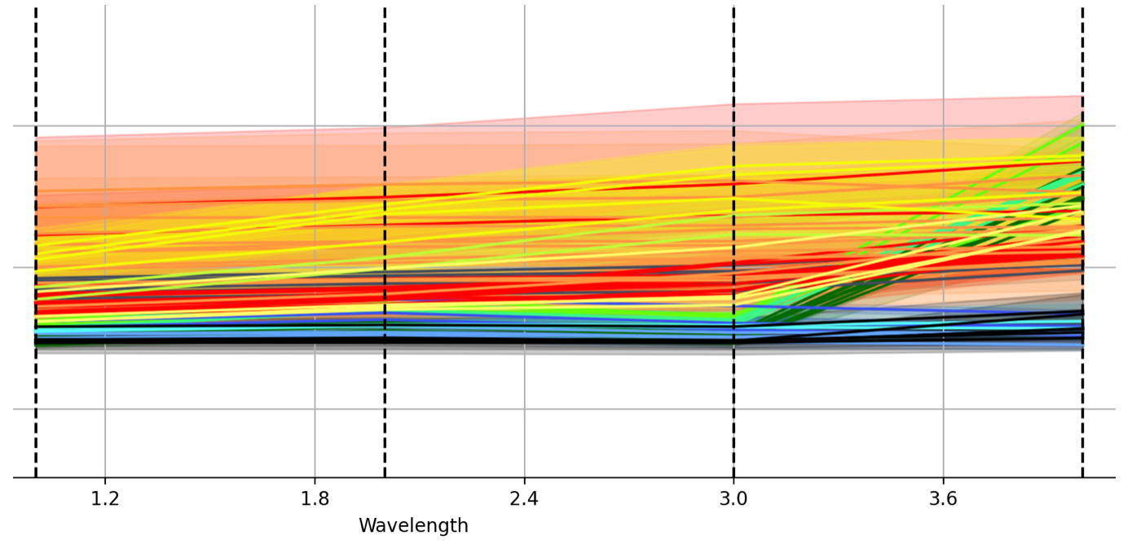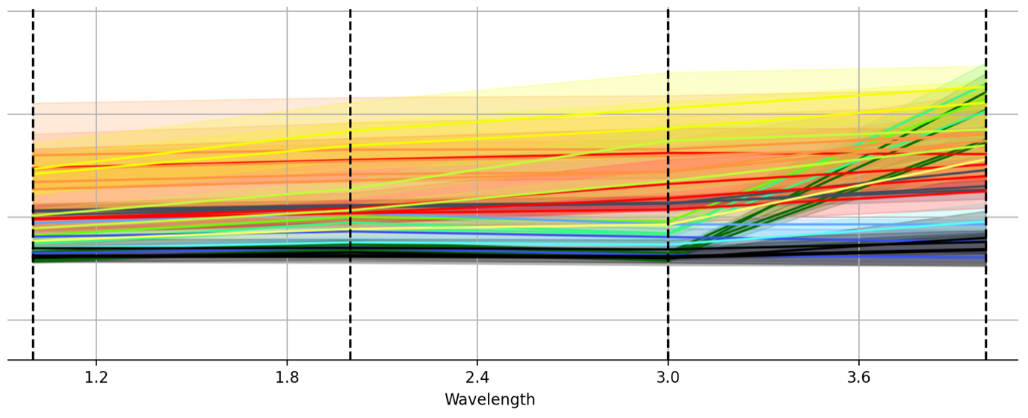

⏶ *Spectral plot of the 2023 training data set*  ⏶ *Spectral plot of the 2023 test data set*

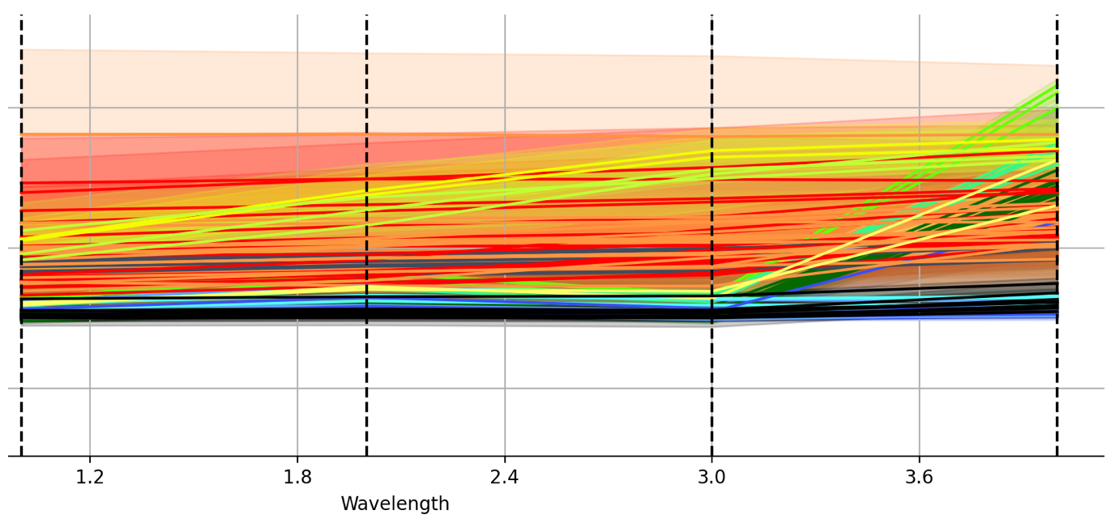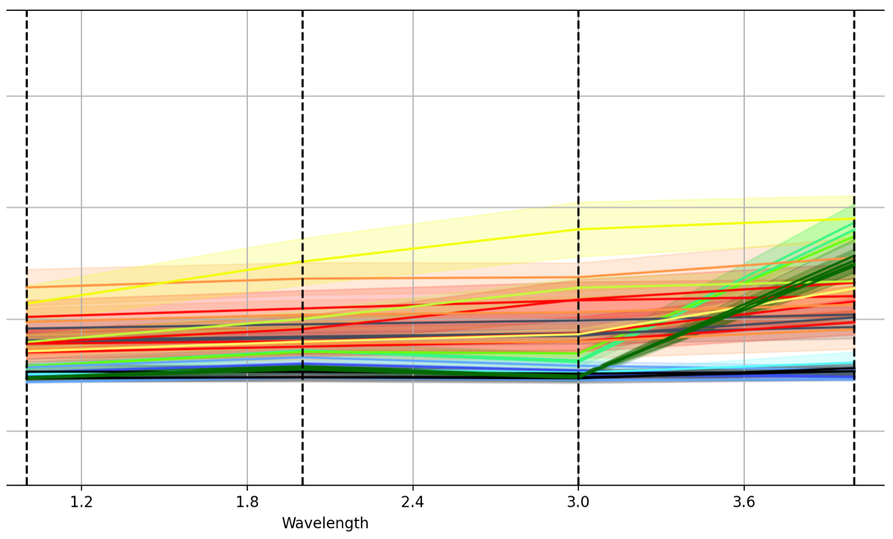

⏶ *Spectral plot of the 2024 training data set*  ⏶ *Spectral plot of the 2024 test data set*

### **4.4 Classification & Accuracy Assessment using SCP Plugin**

After creating training and test data sets for the relevant subclasses, we use the SCP plugin to perform classification using the “post-processing” feature on the selected area:

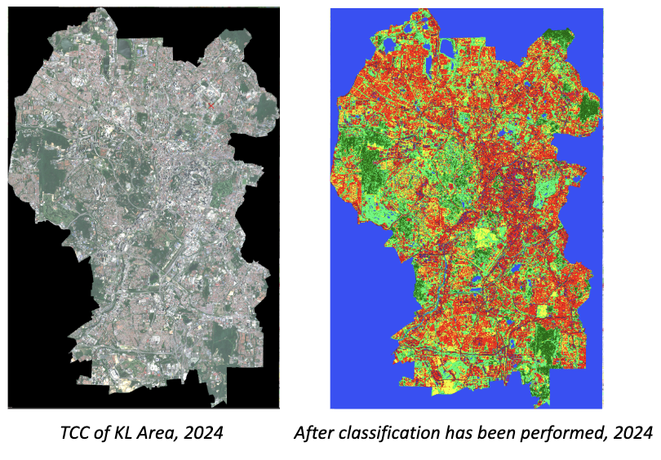

⏶ *A side-by-side comparison of pre- and post-classification of the KL area in 2024*

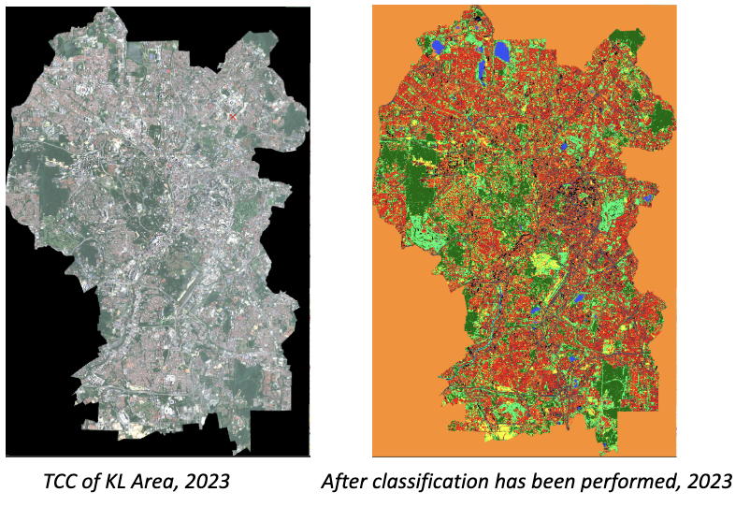

⏶ *A side-by-side comparison of pre- and post-classification of the KL area in 2023*

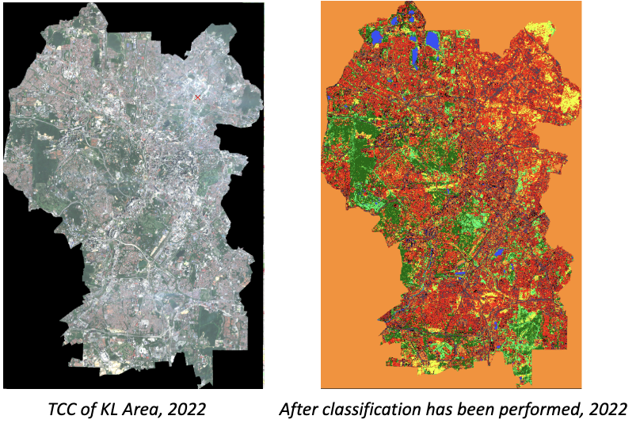

⏶ *A side-by-side comparison of pre- and post-classification of the KL area in 2022*

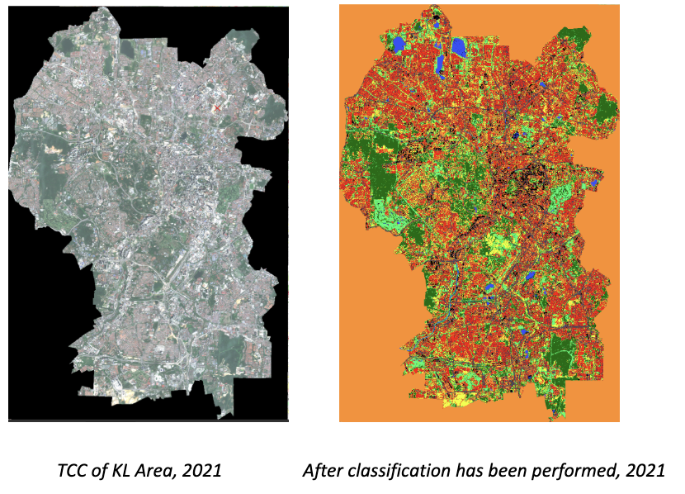

⏶ *A side-by-side comparison of pre- and post-classification of the KL area in 2021*

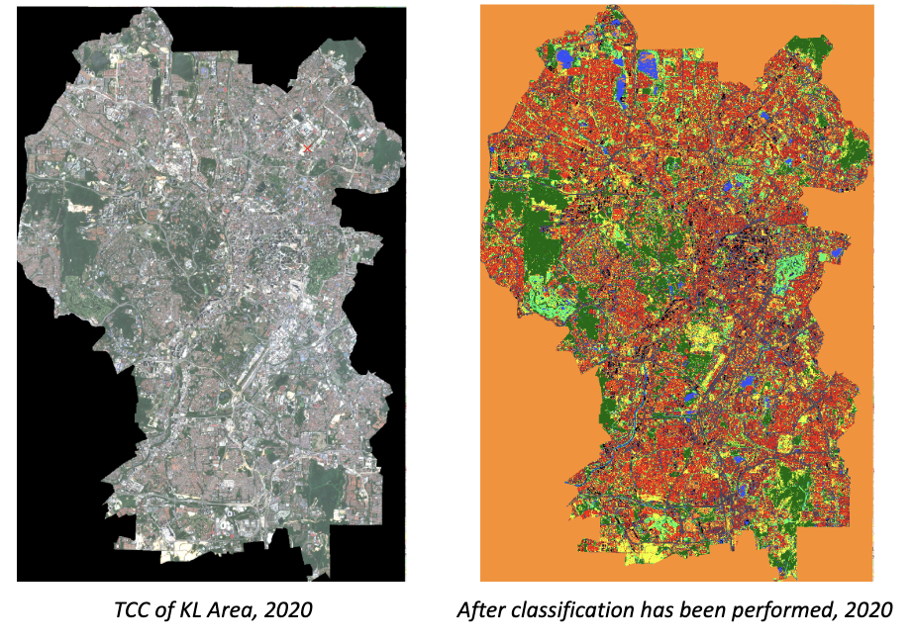

⏶ *A side-by-side comparison of pre- and post-classification of the KL area in 2020*

After classifying the area based on the training and test data, the following accuracy results were obtained for each year:

2024

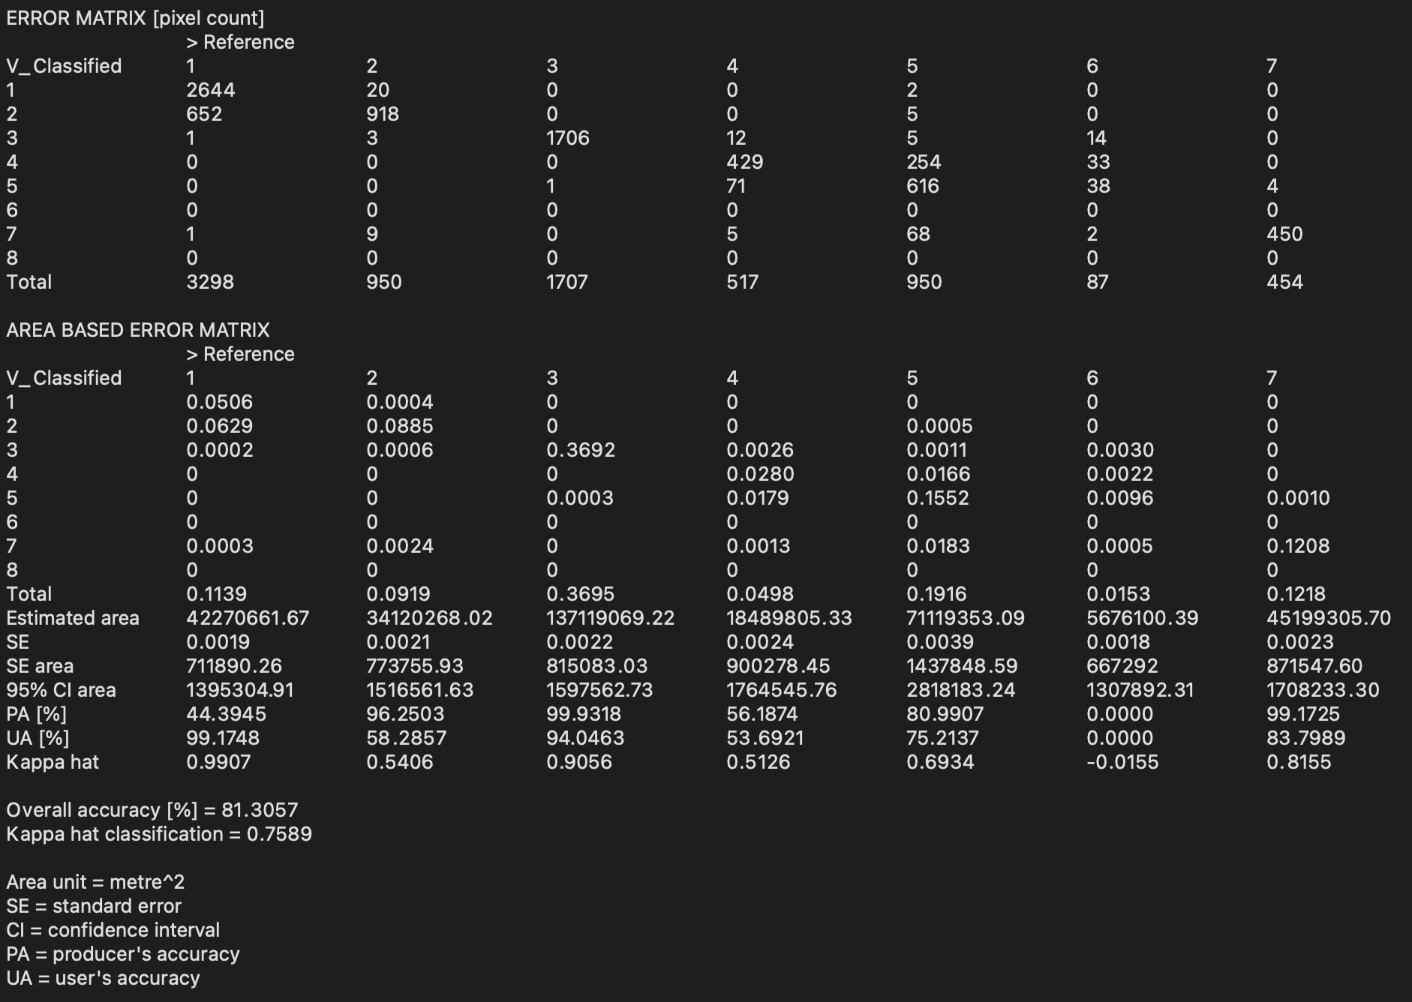

Overall Accuracy: 81.3%

Kappa Hat classification: 0.759

2023

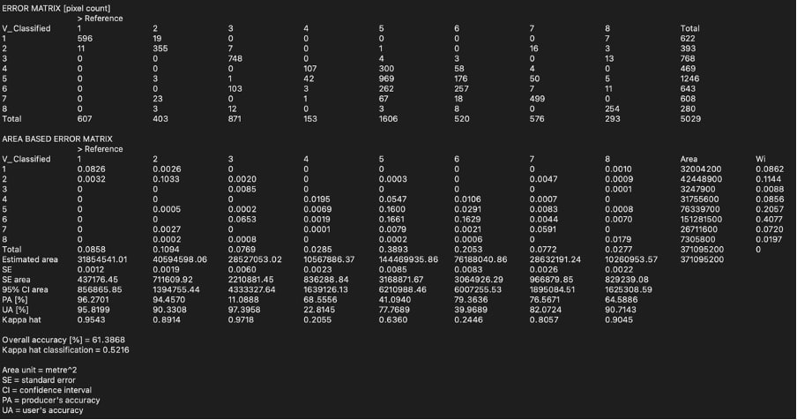

Overall Accuracy: 61.4%

Kappa Hat classification: 0.522

2022

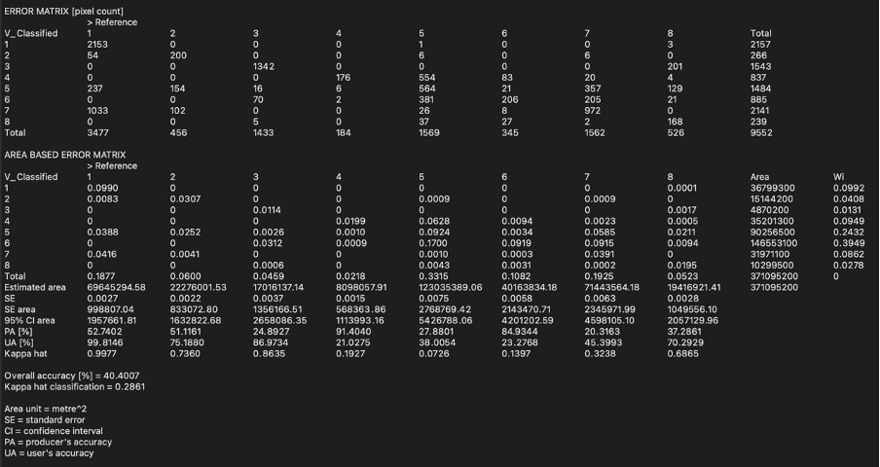

Overall Accuracy: 40.4%

Kappa Hat classification: 0.286

2021

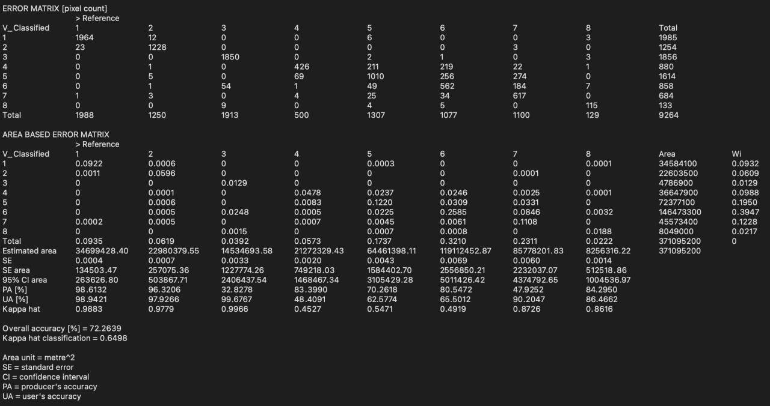

Overall Accuracy: 72.3%

Kappa Hat classification: 0.650

2020

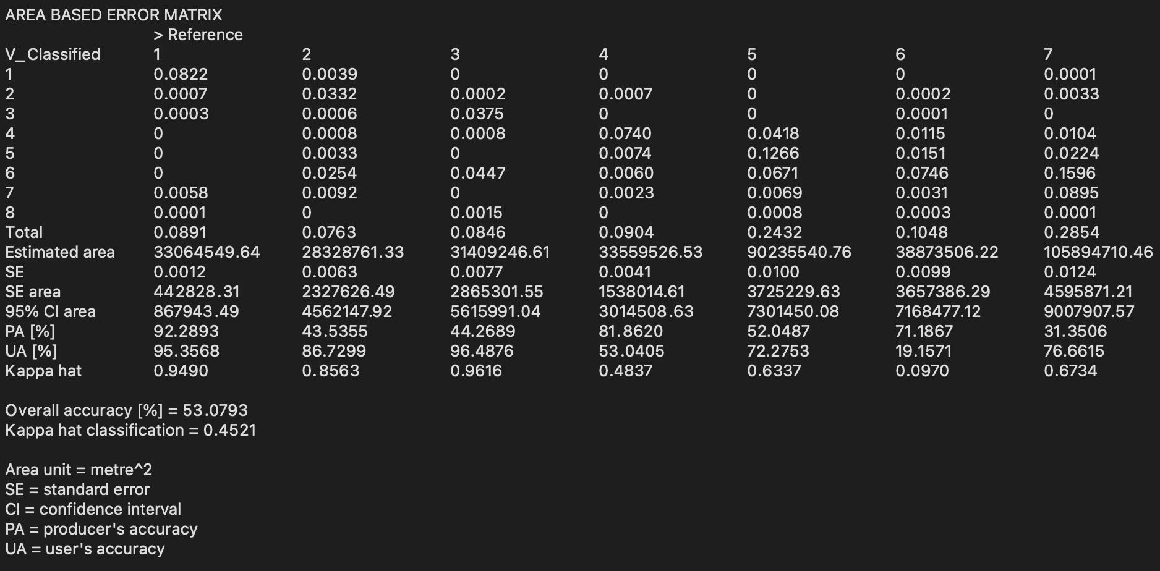

Overall Accuracy: 53.1%

Kappa Hat classification: 0.452

It is advisable for the overall accuracy value of the classification to be 70% or greater and for the Kappa Hat classification value to be 0.65 or greater to ensure that the classification output provides us with the best analysis possible. However, we were unable to obtain these values for many of the years despite taking multiple training/test samples that were distributed across the selected region, which could therefore mean that the accuracy defect was due to poor image quality for selected years. Such shortcomings will be further elaborated in the Limitations section.

## 

## 

## **5.0 Data Analysis & Discussion**

### **5.1 Change in Land Cover of Selected Land Classes**

Given our classification and accuracy values, we have selected the following land classes to focus our analysis on as we believe that these show the most relevance to our problem statement and goal: Vegetation (Natural & Managed), Impervious Surfaces, Water Bodies, Barren Land, Low-Rise Buildings.

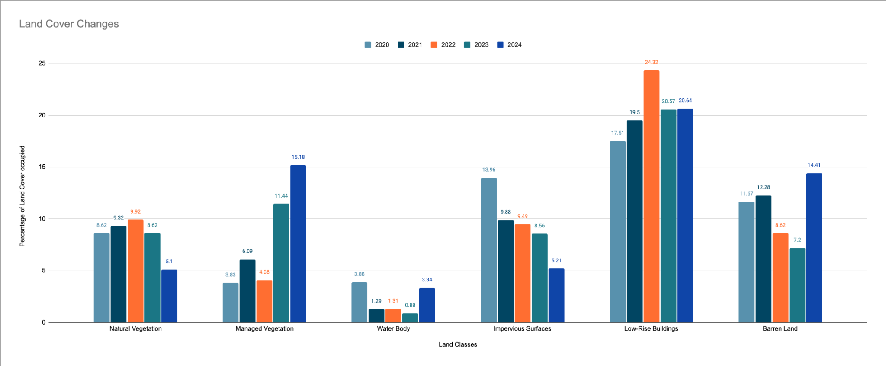

⏶ *Bar chart showing the selected land classes and their composition in the overall KL region over the 5 years*

#### 

#### **5.1.1 Vegetation**

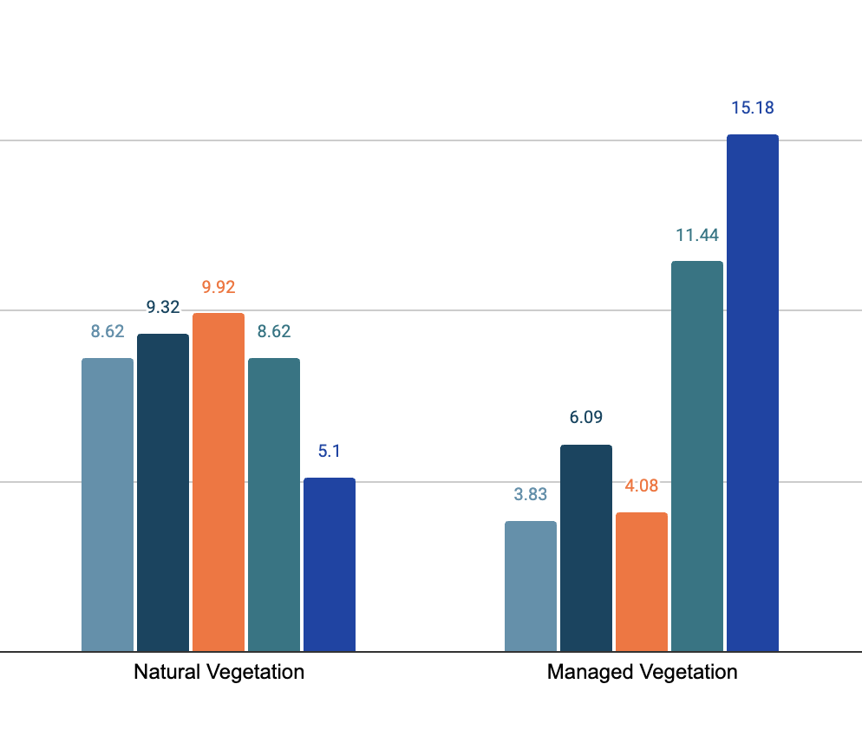

⏶ *Bar chart excerpt showing the composition of the 2 types of vegetations over the 5 years*

For natural vegetation, the figures tend to fluctuate between 8.62% - 9.92% of the total land cover from 2020 to 2023. However, there is a stark decrease (3.52% ) from 2023 (8.62%) to 2024 (5.1%), signalling that there has been some type of an intervening event in 2023 that has affected the percentage of natural vegetation present in the state in 2024.

On the other hand, the chart shows a relatively small percentage of land cover occupied by managed vegetation from 2020 to 2022, with 2021 having the highest value of yet only 6.09%. However, there are notable and consistent sharp increases from 2022 to 2024, with a jump from 4.08% in 2022 to 11.44% in 2023, and a jump from 11.44% in 2023 to 15.18% in 2024. This could reflect greater efforts taken to improve managed greenery and grounds.

#### 

#### 

#### 

#### 

#### 

#### 

#### **5.1.2 Water Bodies**

#### 

⏶ *Bar chart excerpt showing the composition of water bodies over the 5 years*

The composition of water bodies has consistently remained relatively low across all 5 years, with the highest figure being 3.88% in 2020. After a 2.59% drop to 1.29% in 2021, it increased insignificantly to 1.31% in 2022 before decreasing to 0.88% in 2023. Notably, there is a significant 2.46% increase from 0.88% in 2023 to 3.34 in 2024, once again signalling to us that there may have been some type of an intervening event in 2023 that could have resulted in the increase in 2024.

#### **5.1.3 Impervious Surfaces**

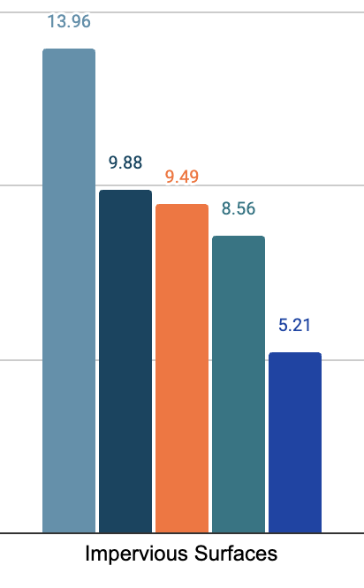

⏶ *Bar chart excerpt showing the composition of impervious surfaces over the 5 years*

Over the 5 year span, there has been a constant decrease in the percentage composition of impervious surfaces (roads) in the state, with 2 significant drops: a 4.08% decrease from 13.96% in 2020 to 9.88% in 2021, as well as a 3.35% decrease from 8.56% in 2023 to 5.21% in 2024. These decreases may be attributed to significant intervening events in 2020 and 2023 respectively. Otherwise, even though it decreased slightly every year (9.88% in 2021 to 9.49% in 2022, 9.49% in 2022 to 8.56% in 2023), the percentage composition did not fluctuate significantly from 2021 to 2023.

#### **5.1.4 Low-Rise Buildings**

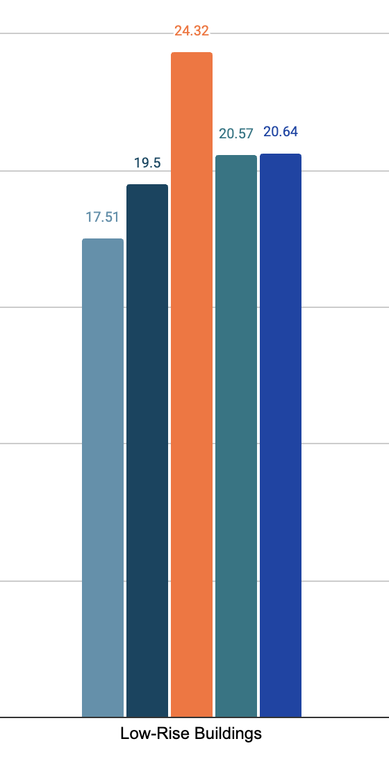

⏶ *Bar chart excerpt showing the composition of low-rise buildings over the 5 years*

The percentage composition of low-rise buildings in the state has consistently been quite high, consistent with the fact that KL is a highly urbanised city. There seems to be consistent increases from 2020 (17.51%) to 2021 (19.50%) as well as from 2021 (19.50%) to 2022 (24.32%), which could be a sign of greater urbanisation. From 2022 to 2023 however, there is a 3.75% decrease from 24.32% (2022) to 20.57% (2023) and no further major increase or decrease after 2023. This could signal efforts to scale back on urban development from 2022 onwards, but further research and information is required to conclusively state anything regarding these figures.

#### 

#### **5.1.5 Barren Land**

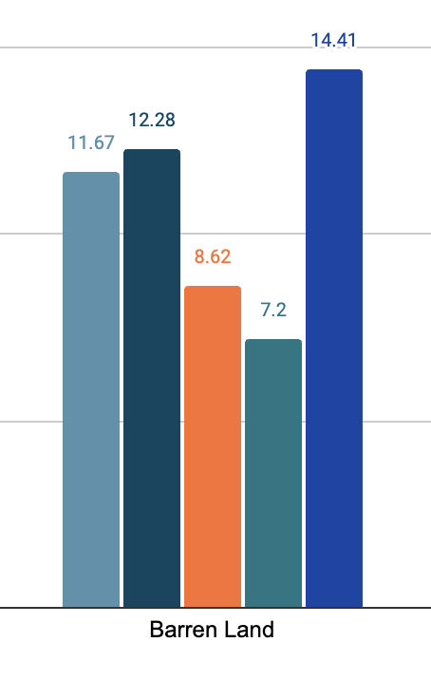

⏶ *Bar chart excerpt showing the composition of barren land over the 5 years*

The percentage composition of barren land present in the state has undergone fluctuations from 2020 to 2024. Barring a somewhat insignificant 0.61% increase from 11.67% in 2020 to 12.28% in 2021, there were 2 more notable decreases: a 3.66% decrease from 12.28% in 2021 to 8.62% in 2022, as well as a 1.42% decrease from 8.62% in 2022 to 7.20% in 2023. These decreases could be because of the usage of barren land for urbanisation and development purposes. Most interestingly, the composition of barren land more than doubles from 2023 to 2024 – a whopping 7.21% increase from 7.20% in 2023 to 14.41% in 2024. This could be attributed to some type of intervening event that has led to some massive clearance of land.

### 

### 

### 

### 

### 

### **5.2 Overall Trend in Land Cover Change**

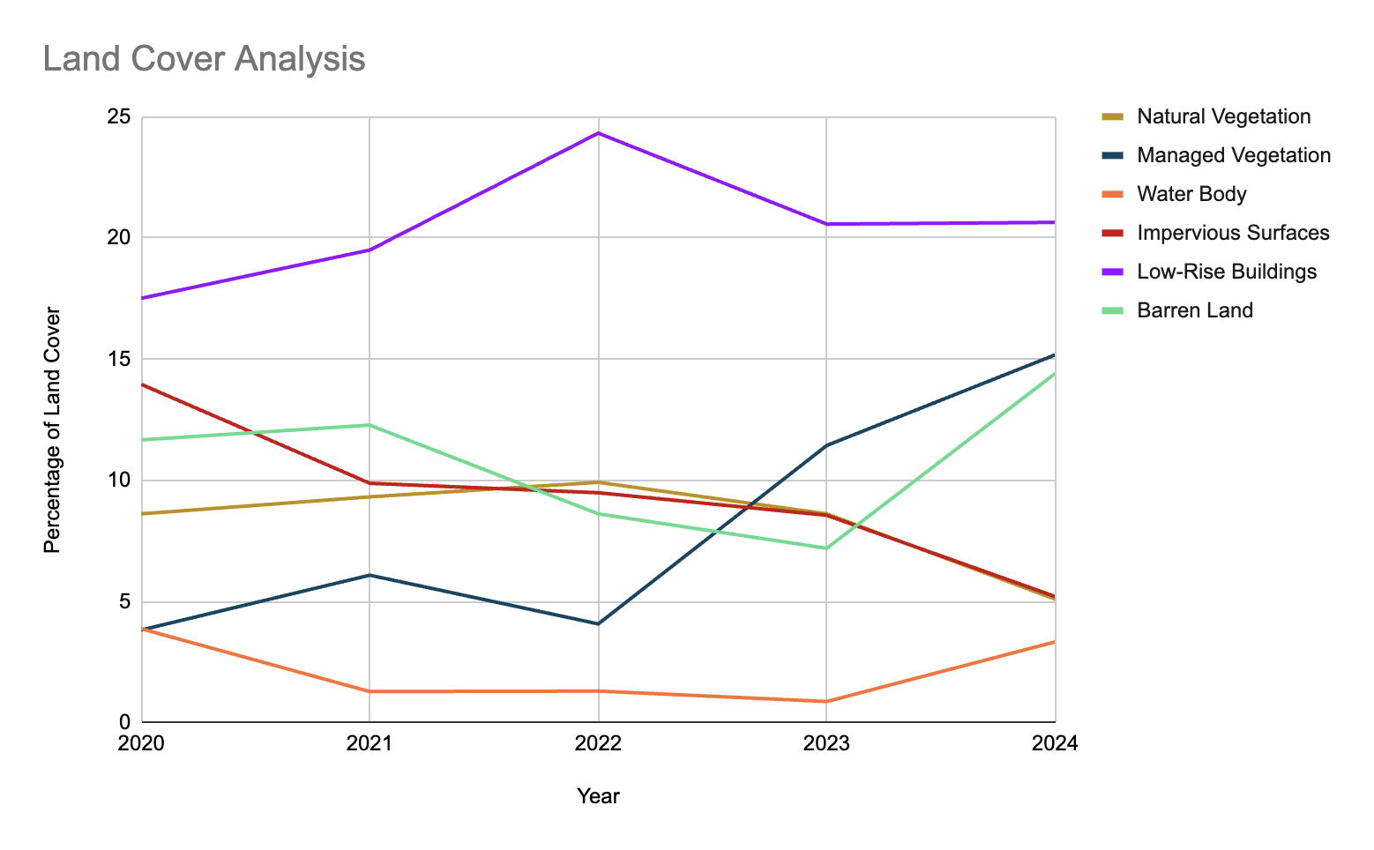

⏶ *Line chart showing the overall trends of the selected land classes over the 5 years*

From the above chart, we are able to observe the following:

1. **Low-rise buildings occupy the greatest percentage of land cover, with a consistent upwards trend**. This shows that there has been a steady increase in urbanisation efforts, with more and more development across the years.
2. **Managed vegetation exhibits a consistent increasing trend, currently even exceeding the proportion of barren land available**. This shows that residential and commercial areas, where managed vegetation is noted to be more commonly present, have remained relatively unscathed by the effects of landslides.
3. **Barren land has not undergone any major increasing or decreasing trend, but does exhibit sharp increases/decreases between years**. This could be due to the sudden nature of landslides and other intervening events that destroy anything present on the land, creating more barren land and this would explain the sharp increase(s). When this happens, rebuilding and rehabilitation efforts are often taken up immediately, once again reducing the barren land available, explaining the sharp decrease(s).
4. **Both natural vegetation and impervious surfaces have shown a consistent decreasing trend**. Both these land classes could have been affected by
   1. Urbanisation effects which call for deforestation (thereby reducing natural vegetation) and redevelopment (thereby requiring the demolition of roads [impervious surfaces]) as well as,
   2. Landslides, which have the ability to destroy everything on the ground as well as the ground itself, which means that both forested areas and naturally-vegetated areas, as well as roads and other infrastructure.
5. **Water bodies occupy the lowest percentage of land cover, with no significant observable trend**. As a landlocked city-state, it is not possible to have water bodies such as the sea. However, flash floods, excessive rainfall and other water-related intervening events could increase/decrease the volume of water present in reservoirs, rivers and lakes, which would explain the slight fluctuations observed in the line chart.

Ultimately, these patterns reflect how urban sprawl into hilly, vegetated regions may have intensified environmental vulnerability while leaving core urban centres less directly affected.

### **5.3 An Example of our Observations: Bukit Tunku**

Our above data analysis provides us with a broad snapshot of the type of land cover changes that have happened over the span of 5 years. Given the size of the area we have chosen to analyse, we wish to focus this section of our analysis on a major landslide that could grant us greater insight into the overall trends we have observed. We also lack sufficient information and time to replicate this analysis for all landslides that happened. Therefore, we focused on specifically the 2023 Bukit Tunku landslide given its scale and the damage it created to illustrate the devastating effects landslides can have on land cover.

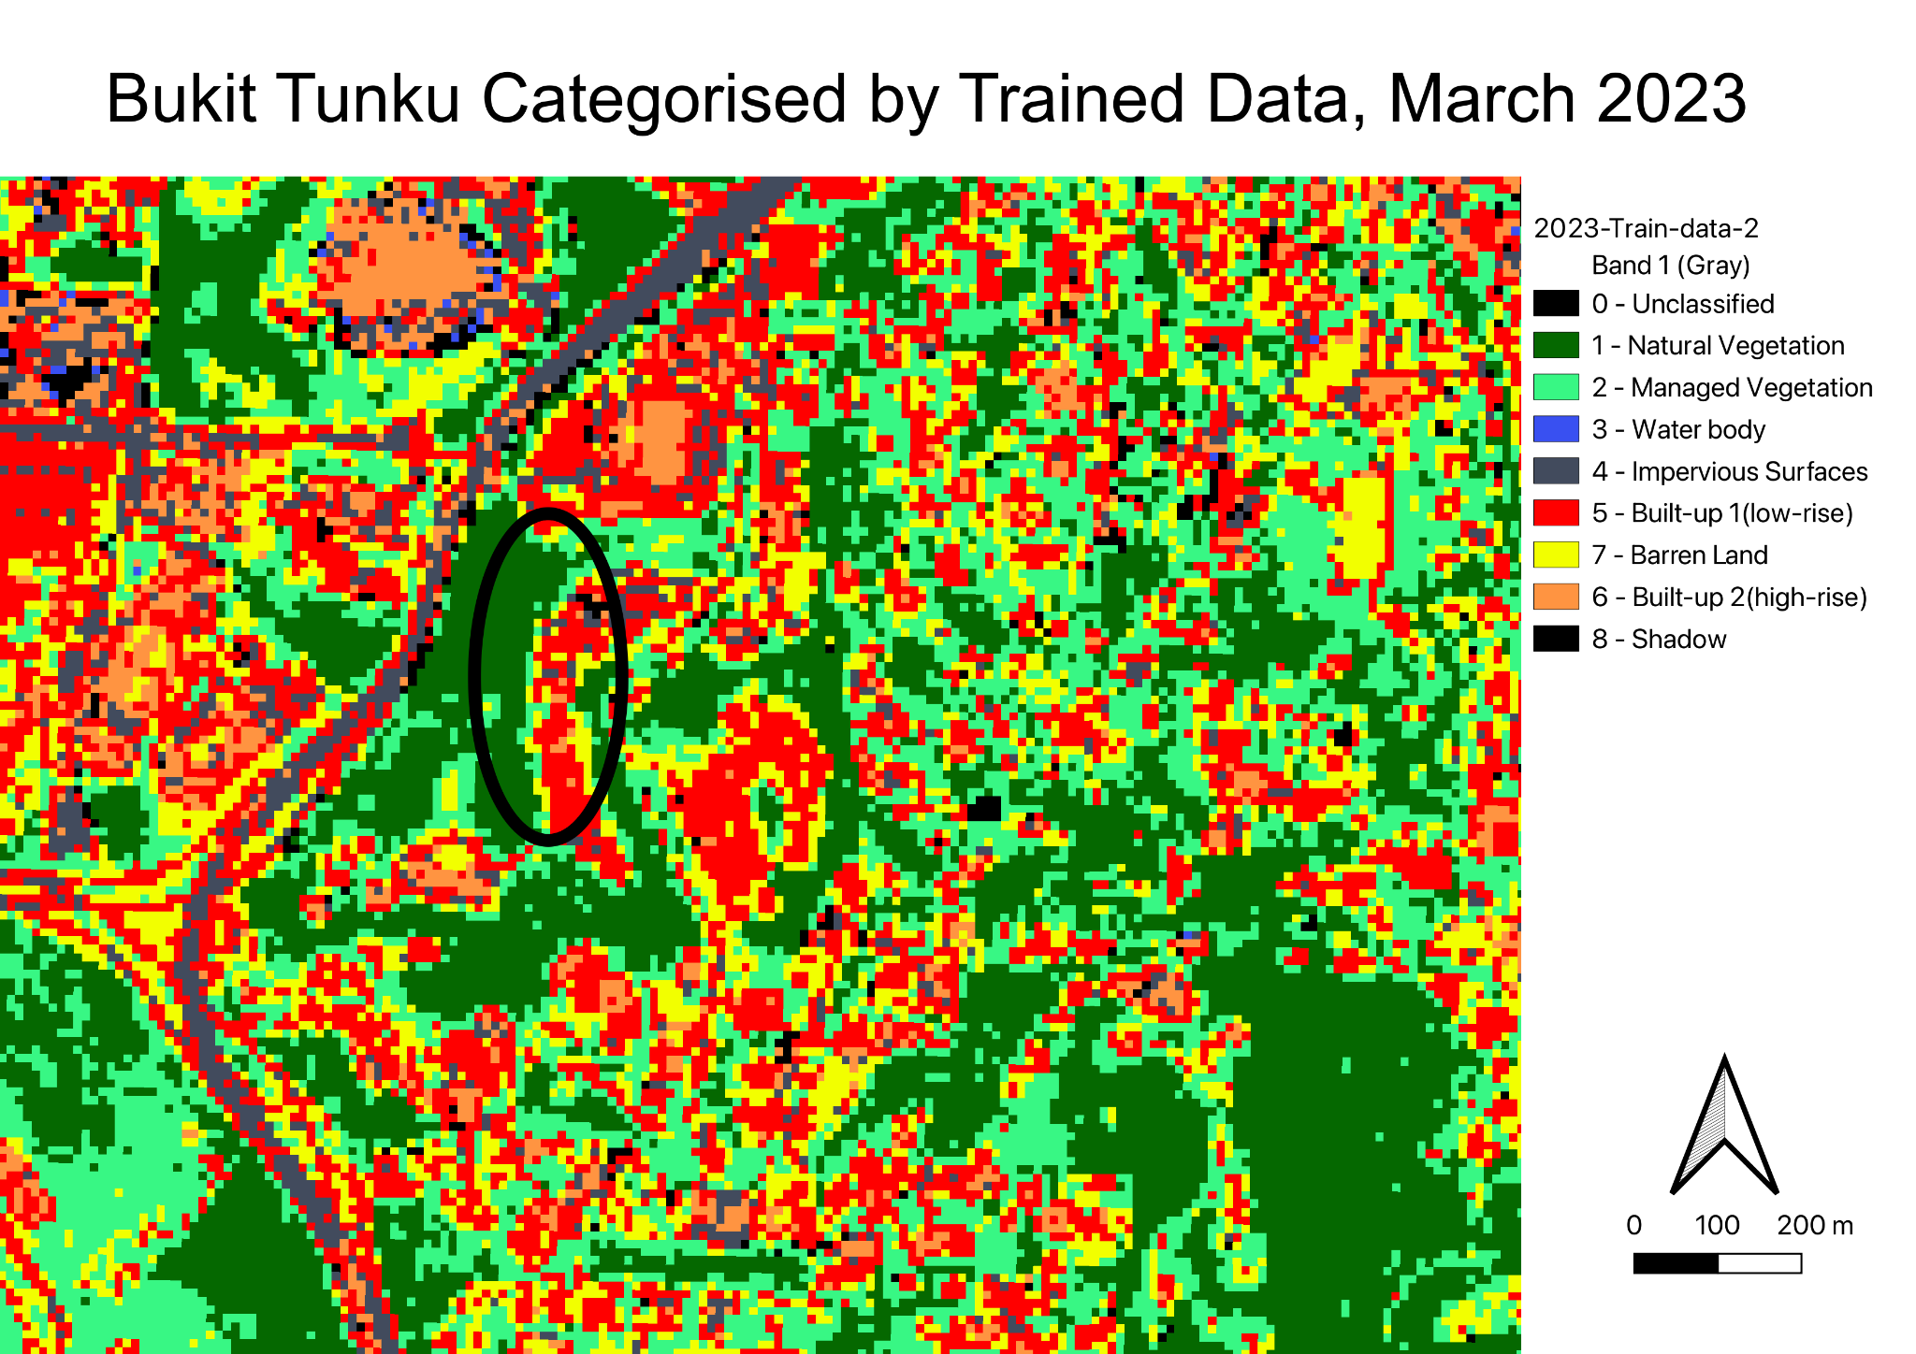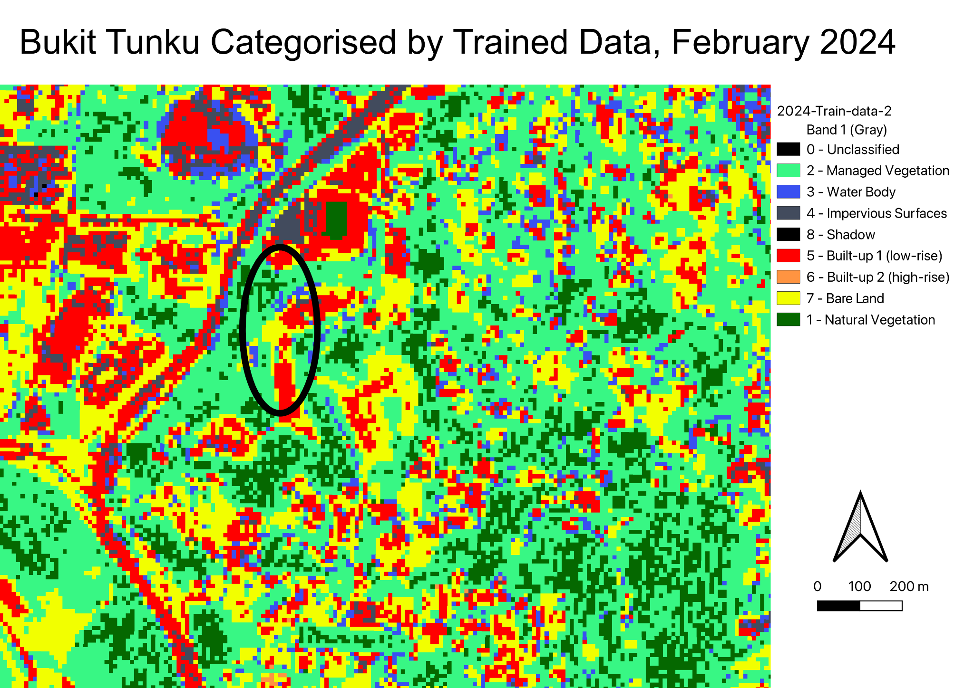

⏶ *A side-by-side comparison of the land cover at Bukit Tunku before and after the 2023 landslide*

From the indicated parts on the maps, we are able to observe that there has been a loss of low-rise building(s) and an increase in barren land. This is consistent with what was observed in the aftermath of the landslide, which occurred near the Malaysian Anti-Corruption Academy at Persiaran Tuanku Syed Sirajuddin in Bukit Tunku. Interestingly, we are also able to observe from the above line graph that barren land has increased sharply from 2023 to 2024 and that natural vegetation has decreased in that same time frame.

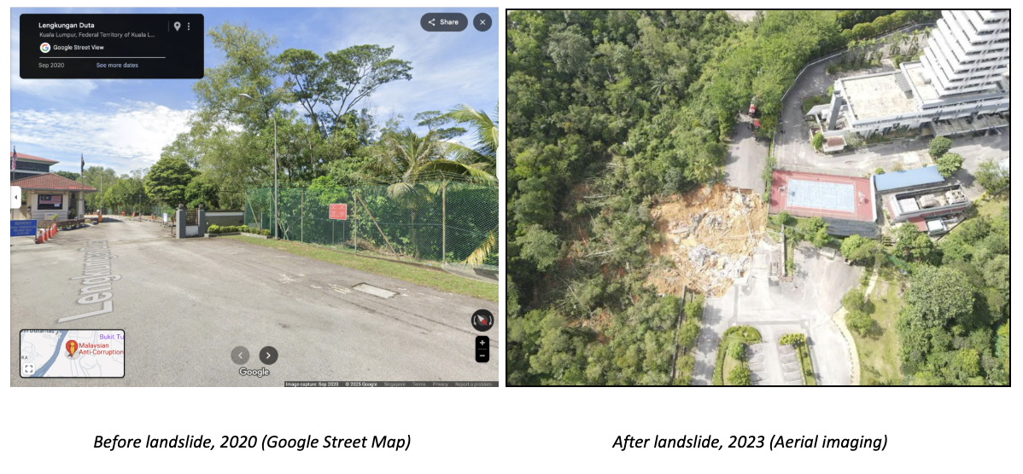

⏶ *A side-by-side comparison of MACA at Bukit Tunku before and after the 2023 landslide*

While it would be myopic to conclude that this one landslide alone would have caused such drastic changes in land cover, especially for the natural vegetation and barren land classes, such events are consistent with the trends observed as a whole.

## **6.0 Limitations**

Throughout this project, we faced many limitations:

1. **Lack of sufficient, accurate information:** We struggled with finding vector layer data that represented the KL region accurately and the data that we could find was quite pixelated, blurry and did not fit the actual geographical boundaries of the state within Malaysia precisely enough. Beyond this, we also struggled to find sufficient information on the actual number of landslides that occurred in Malaysia/KL due to faults in reporting, inaccessible reports (paywalled/requires special access) as well as language barriers.
2. **Classification troubles:** Given the type of data we were working with, we struggled to obtain accurate classification values. Some of the vector layer imaging that we used were not sufficiently detailed and often had blurry, pixelated visualisation, which meant that the SCP plugin was more likely to classify ROI polygons belonging to certain land classes into the wrong land classes. For example, the SCP plugin struggled very much with distinguishing between ROI polygons originally selected from roads (Impervious Surfaces) and polygons selected from rivers (Water Bodies), which meant that our accuracy values specifically for those land classes were greatly affected across the years.

## **7.0 Recommendations**

Given the data we have analysed, the trends we have observed and the conclusions we have drawn, we believe that the following would be apt recommendations to ensure that the likelihood of landslides are reduced and environmental risks are mitigated while balancing the need for urbanisation:

1. To stop landslides and degradation, stricter rules should be implemented for construction in high-risk slopes and sensitive hilly areas.
2. In order to preserve slope stability and natural drainage, forest conservation initiatives should place a high priority on protecting and restoring forests, particularly those that are close to urbanising areas.
3. To control excessive rainfall and lessen flooding, landslide-prone communities need to upgrade their infrastructure and urban drainage systems. Furthermore, integrating geospatial monitoring tools like GIS and remote sensing into urban planning will aid in the early detection of land deterioration.
4. Since they will support both urban growth and environmental resilience, sustainable urban green initiatives like urban forests and green roofs should be encouraged.

## **8.0 Future Work**

We believe that our current project is quite limited for us to conclude anything concrete about the relationship between landslides and land cover change due to the restricted level of analysis that has been conducted. To expand on this issue and further the understanding on our chosen topic, we believe the following changes can be implemented in future works:

1. **Wider Study Area:** In order to evaluate the wider impacts of urbanisation, floods, and landslides on land cover, include nearby areas of Kuala Lumpur such as Selangor (e.g., Putrajaya, Petaling Jaya) which have more hilly terrain.
2. **Use Multi-source Data:** Combine information such as infrastructure development or population density to have a better understanding of the factors influencing change, or use terrain analysis (slope) to predict and pinpoint vulnerable regions at risk of landslides, using data obtained from past landslides, such as the Bukit Tunku case.
3. **Extend Temporal Analysis:** To enhance environmental effect forecasts, we could look to extend the study period to examine long-term trends (by investigating barren land used for land development projects and how surrounding land cover has changed before and after, to predict the possibility of landslides ) or carry out seasonal monitoring by tracking monsoon-driven changes using quarterly composites.

## **9.0 References**

Florida, R. (2017). *Does Urbanization Drive Southeast Asia’s Development?* Bloomberg. https://www.bloomberg.com/news/articles/2017-01-18/how-urbanization-is-driving-southeast-asia-s-economies

Lu, W., Xiao, Z., Chen, Y., Sun, J., & Chen, F. (2024, May 14). *Spatiotemporal characteristics and rainfall thresholds of Geological Landslide Disasters in ASEAN countries*. MDPI. <https://www.mdpi.com/2073-4433/15/5/599#:~:text=Prolonged%20or%20heavy%20rainfall%20can%20saturate%20soil%2C,a%20sudden%20increase%20in%20pore%20water%20pressure>.

Miniandi, N. D., Muhammad, M. K., Jamal, M. H., & Shahid, S. (2024, June 17). *Urbanization signature on hourly rainfall extremes of Kuala Lumpur*. Sustainable Cities and Society. https://www.sciencedirect.com/science/article/abs/pii/S2210670724004359#:~:text=Malaysia%2C%20one%20of%20the%20fastest,often%20leading%20to%20flash%20floods.

Petley, D. (2023, April 27). *The 25 April 2023 landslide Bukit Tunku in Malaysia*. The Landslide Blog. https://blogs.agu.org/landslideblog/2023/04/27/bukit-tunku-landslide-1/

Sim, K. B., Lee, M. L., & Wong, S. Y. (2022, January 25). *A review of landslide acceptable risk and tolerable risk - geoenvironmental disasters*. SpringerOpen. https://geoenvironmental-disasters.springeropen.com/articles/10.1186/s40677-022-00205-6#:~:text=Malaysia,Abd%20Majid%20and%20Rainis%202019).

*Understanding landslides*. British Geological Survey. (2021, June 14). https://www.bgs.ac.uk/discovering-geology/earth-hazards/landslides/

UN-Habitat malaysia country programme overview 2023- ... (2023). https://unhabitat.org/sites/default/files/2023/06/8._un-habitat_malaysia_country_document_short_version_june2023.pdf

US Department of Commerce, N. (2015, August 10). *Flood and flash flood definitions*. National Weather Service. https://www.weather.gov/mrx/flood_and_flash

Zulkafli, S., & Majid, N. (2020). L*andslides Incidents in Federal Territory of Kuala Lumpur, Malaysia*. https://www.envirobiotechjournals.com/EEC/v27i32021/EEC-53.pdf

Zulkafli, S., Majid, N., Syed Zakaria, S., Rahman, M. R., & Ahmed, M. (2023). *Influencing Physical Characteristics of Landslides in Kuala Lumpur, Malaysia*. Pertanika Journals. http://www.pertanika.upm.edu.my/resources/files/Pertanika%20PAPERS/JST%20Vol.%2031%20(2)%20Mar.%202023/18%20JST-3571-2022.pdf